Main Menu Choices

In this document we present the choices that are available in the main menu for each kind of actor. The choices for not authenticated users are shown in the PDF document called “Master-page.pdf”.

# Consumer

A user authenticated as a consumer will have five choices: Catalogue, Shopping cart, Orders, Messages and Log out. Each choice redirects to a different view and doesn’t have any submenu.

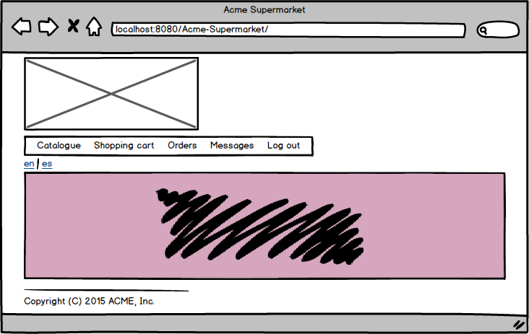

# Administrator

A user authenticated as an administrator will have six initial choices: Manage, List, Dashboard, New Clerk, Messages and Log out.

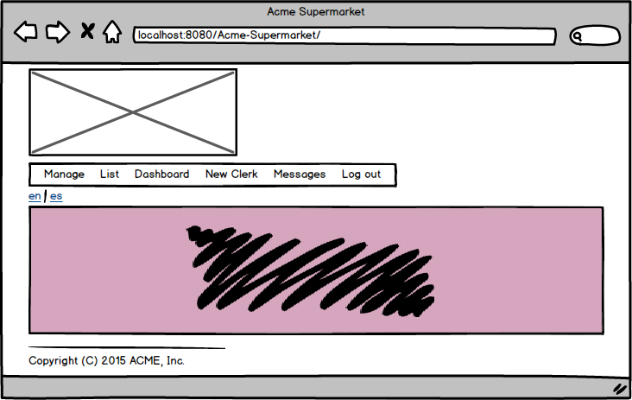

By placing the cursor on the Manage option (the system won’t have any function by clicking on it) will appear a submenu that will display four new choices: Catalogue, Taxes, Categories and Warehouses. Each choice redirects to a different view and doesn’t have any submenu.

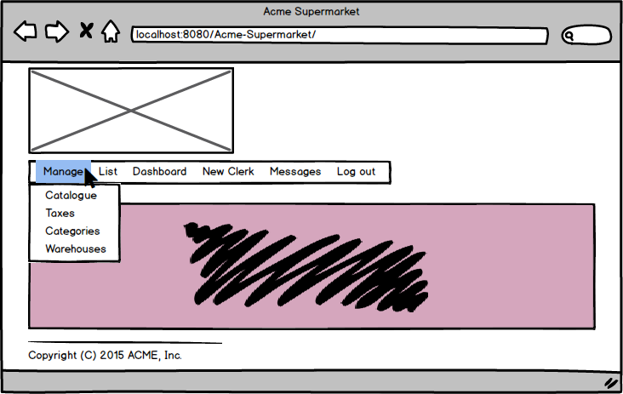

By placing the cursor on the List option (the system won’t have any function by clicking on it) will appear a submenu that will display two new choices: Consumers and Orders. Each choice redirects to a different view and doesn’t have any submenu.

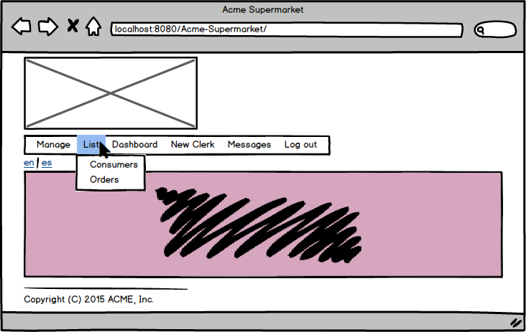

Each of the other choices redirects to a different view and doesn’t have any submenu.

# Clerk

A user authenticated as a clerk will have five choices: Catalogue, Warehouses, Orders, Messages and Log out. Each choice redirects to a different view and doesn’t have any submenu.

